Rathdown Heritage Park Biodiversity Plan

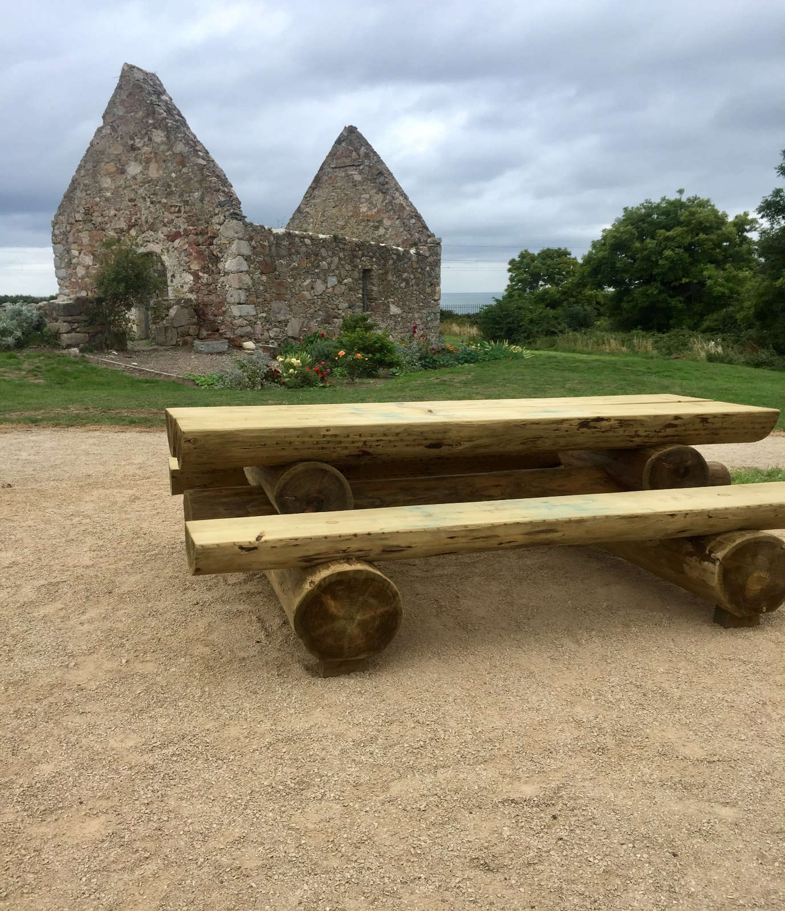

Oran O’Sullivan, August 2018, www.irishgardenbirds.ie

Contents
Project Brief & methodology page 2
Site History page 2
Rathdown Nature Park / St Crispins: its place in the landscape page 3
Biodiversity page 4
Pollination page 5
Actions for Protection and Enhancement of Biodiversity page 6
Habitats at St Crispins page 7
Grassland page 8
Woodland page 10
Stream page 11
Hedgerows page 12
Stone Buildings page 12
Conclusions / Recommendations page 13
Appendices page 15
References and Bibliography page 18

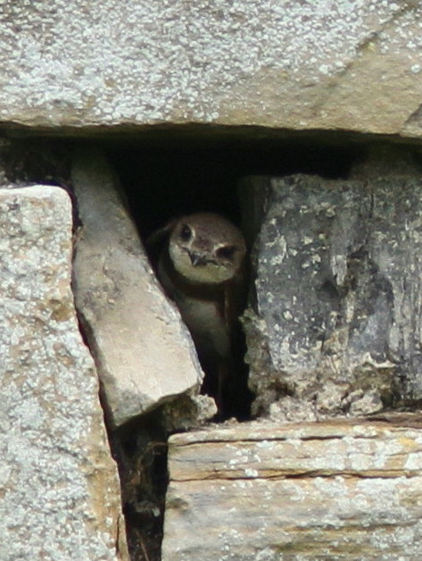
Figure 1 Sand Martin in nest hole

Project brief
In June 2018 The Heritage Office of Wicklow County Council commissioned a study that proposes ways to manage the Rathdown Heritage Park to benefit wildlife, enhance and maximise the biodiversity potential whilst respecting the archaeological integrity and community interest of the site. This study will complement the Rathdown Heritage Park Design Strategy (Morgensen, December 2014).
The principal aim of this council-led initiative is to increase the awareness of the importance of biodiversity in the Rathdown community and empower individuals and groups to make positive contributions for the benefit of both wildlife and people. This biodiversity plan was drawn up following a review of the existing biodiversity resources and a series of workshops in the community which provided training in biodiversity awareness and allowed collaboration to identify projects to conserve and enhance biodiversity. An emphasis was placed on incorporating the objectives of the All-Ireland Pollinator Plan 2015 - 2020 into the biodiversity projects. This national plan proposes actions that will increase habitat and food sources for a range of pollinating insects and provides a useful foundation from which other biodiversity related projects can evolve. The aim of this project is to strive for greater community participation to ensure that as many people as possible are made aware of the value of biodiversity in their localities.

PROJECT METHODOLOGY AND APPROACH
The underlying theme of this project is to identify practical opportunities for community led actions for biodiversity. A walkover meeting was conducted with representatives of the Tidy Towns and Rathdown Residents group in June 2018, to review and identify areas of biodiversity interest and opportunities for projects within the site.
Planning Context
The site lies within the administrative areas of Wicklow County Council and Greystones, Delgany, Kilcoole Municipal Area. It is mentioned specifically in the Local Area Plan (LAP) 2013-2019 and the Greystones Harbour and North Beach Action Area Plan (AAP). The objectives and the various protections are summarised in the Rathdown Heritage Park Design Strategy, (2014), section 5 page 8.

Site History
The Site contains the ruins of St. Crispin’s Cell and Captain Tarrant’s Farmhouse and Outbuildings. The site also contains evidence of pre-historic, early Christian, medieval and post-medieval settlements. The ruins are all Protected Structures and the site itself is protected under the Greystones Local Area Plan which seeks ‘to protect the character of this area as a heritage and amenity area for public amenity and education’
In recent years the site and the buildings became overgrown and neglected and vandalism in the form of graffiti and littering was rampant.
Bearing this in mind, a local Urban Design and Planning Consultant, in cooperation with Greystones Tidy Towns, prepared the ‘Rathdown Heritage Park Design Strategy’ which suggests reviving the site, using a bottom-up and phased approach that can be carried out as funding becomes available. In December 2014 the ‘Strategy’ was officially submitted as a contribution to ‘Wicklow County Development Plan 2016-2022’ and to the ‘Local Economic and Community Plan’. The ‘Strategy’ provides a comprehensive description as well as maps and drawings of the present St. Crispin’s and of the interventions that are suggested in order to develop the site to become the ‘Rathdown Heritage Park’.

Recent history: Plans and work completed.
The above ‘Strategy’ has informed the undertaking of a series of works and projects in recent years by Greystones Tidy Towns group and Wicklow County Council.
- Clean-up and litter removal in 2014
- Greystones Tidy Towns secured funding for heritage interpretation signs and geophysical survey to identify sub surface archaeology (2015 -2017).
- A footpath was constructed through the site by Wicklow County Council in 2015/16;
- Conservation works completed under the BHIS on St. Crispin’s Cell, 2016
- Heritage Week events held in 2017 and 2018.
- 3 outdoor seats and tables placed at intervals along the main path, 2018
- Paths resurfaced, 2018
- Interpretive sign enhanced, 2018
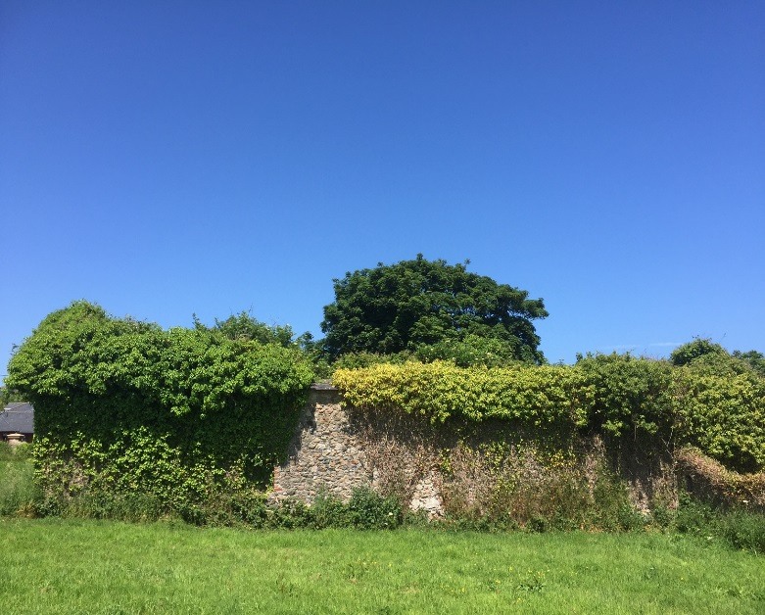
Figure 2 South wall of Captain Tarrant's farmhouse

Rathdown Heritage Park / St. Crispin’s: its place in the landscape.
The Rathdown Heritage Park / St. Crispin’s is a 2 hectare site owned and managed by Wicklow County Council. It is located to the north of Greystones between the sea and residential areas from where it provides local access to the east of the railway line and to the Bray to Greystones Cliff Walk and Greystones North Beach.
The Site contains the ruins of St. Crispin’s Cell and Captain Tarrant’s Farmhouse and Outbuildings. The site also contains evidence of pre-historic, early Christian, medieval and post-medieval settlements. The ruins are all Protected Structures and the site itself is protected under the Greystones Local Area Plan which seeks ‘to protect the character of this area as a heritage and amenity area for public amenity and education’

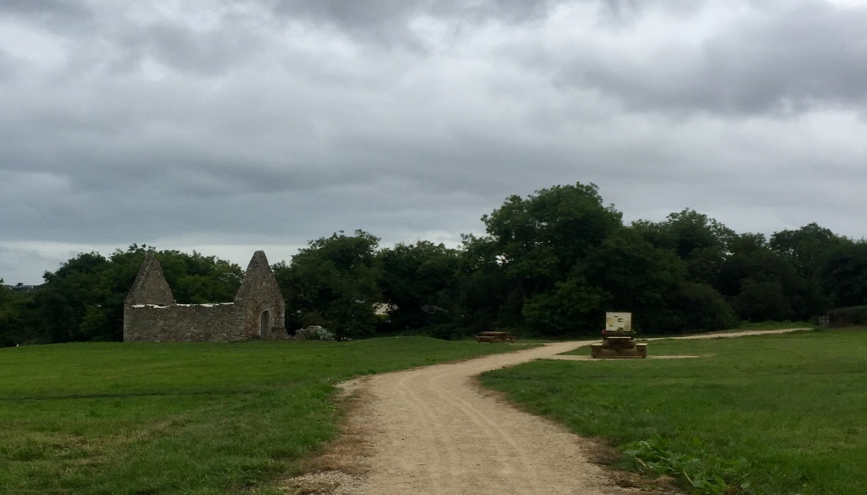
Figure 3 a well maintained path with interpretative sign and outdoor seating area, august 2018

Biodiversity
Why Does it Matter?
Biological diversity or “biodiversity” means the variety of all life forms on Earth. We as human beings are an integral part of biodiversity and we can influence it in a positive or negative way. Biodiversity provides us with food, fuel, medicines and other essentials that we simply cannot live without and is a critical component of the services that nature provides free of charge to all of human society. In the words of Ban Ki-moon, former Secretary General of the United Nations, “…biodiversity underpins the functioning of the ecosystems on which we depend for food and fresh water, health and recreation, and protection from natural disasters. Its loss also affects us culturally and spiritually. This may be more difficult to quantify, but is nonetheless integral to our wellbeing.” It is generally accepted that we all have a moral duty to endeavour to look after the planet and its habitats and species for our own benefit and that of future generations.
There are three main components of biodiversity:
• Species: A distinct group of organisms (living things) capable of successful breeding, i.e. producing offspring.
• Habitats: A place where an organism lives. Habitats provide a mosaic of sufficient food, water and shelter for its inhabitants. In addition, the habitat must support more than an individual of each species type to ensure population continuity through breeding.
• Genes: The genetic makeup of an organism is unique. It is a combination of the parents that produced it (unless it was produced asexually in which case it is a clone of its parent). Variety in the gene pool allows species to overcome or avoid disease and to adapt and evolve to a changing environment. Interacting together, species, habitats and genes make biodiversity what it is.
Humans are a component of biodiversity and we are dependent on biodiversity to provide a range of ecosystem services. Human activities such as agriculture, forestry and fishing depend on services provided by biodiversity. We rely on biodiversity for the provision of clean air and water, food and medicines, natural landscapes, flood control, noise pollution control and much more. A healthy environment is important for human health and well-being. Biodiversity provides us with natural amenities to enjoy, parks and green spaces, wildlife and landscapes to admire and thus improves our quality of life. It is estimated that all these benefits and services provided by biodiversity are worth billions in monetary terms on a global scale.

According to the United Nations Food and Agriculture Organisation, 40% of the world’s economy is based directly or indirectly on the use of biological resources. This provides one of the most compelling reasons for the protection of ecosystems, habitats and species.

Pollination
The importance of POLLINATION
In plants, the transfer of pollen between flowers of the same species by animals, wind, water and in some instances by self-means, results in fertilisation which is necessary to enable plants to produce seeds. This process is known as pollination. For wildlife, this provides fruit and seeds for animals to eat and the persistence of wildflowers in the landscape. For humans, this means we have a range of fruit and vegetables to eat. Many plants produce nectar to entice insects, especially bees and flies, to visit and they in turn carry pollen between flowers. Unfortunately, many of our wildflower habitats such as meadows have been lost, resulting in a decline in pollinator species.
While other insects play a role, most pollination of crops and wild plants on the island of Ireland is carried out by bees. There are 98 different species (types) of bees in Ireland. We have one honeybee, 20 different bumblebees and 77 different solitary bees. Bumblebees and solitary bees are known as wild pollinators. Research tells us that if we want our crops and wild plants to be pollinated we need an abundance and diversity of wild pollinators as well as healthy honeybees.
Honeybee
Honeybees live in hives and are looked after by beekeepers. Beekeepers make sure the honeybees are healthy and have enough to eat, especially over the winter months. Honeybees are the only type of bees in Ireland who make honey.
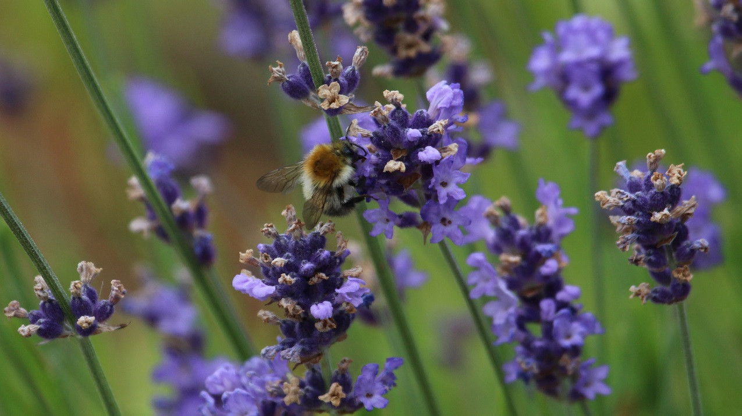
Figure 4 Bumble bee on lavender
Bumblebees
Bumblebees have fat, furry bodies. They are very important pollinators of crops like strawberries and tomatoes. Bumblebees make their nests on the ground, hidden in long grass or other vegetation. Like honeybees, bumblebees live in a colony with a queen, female workers and males. Queen bumblebees hibernate over winter and emerge in spring to begin their colony. To survive, it is vital that bumblebees have food from spring through to autumn. In late summer-autumn mated new queens need to fatten up before going into hibernation, while all the other bumblebees, including the old queen, die off.
Solitary bees
Solitary bees nest in tiny burrows that they make in bare soil or in cavities like holes in wood or hollow stems. Solitary bees exist as a single male and female. They emerge from hibernation in spring and make a nest. After mating, the female lays fertilised eggs and leaves a food supply of pollen beside each one. When this job is complete, the females and males die. The eggs hatch and the larvae eat the food supply left by the parent before overwintering in a cocoon to emerge the following spring.

Pollinator Declines
One third of our 97 wild bee species are threatened with extinction in Ireland. We are also seeing declines in honeybee numbers. Bees are declining because we’ve drastically reduced the areas where they can nest and the amount of food our landscape provides for them. We’ve also inadvertently introduced pests and diseases that negatively impact their health, and we subject them to levels of pesticides that make it difficult for them to complete their life cycles.
What Can We Do To Help Our Pollinators?
If we want pollinators to be available to pollinate our crops and wild plants for future generations we need to manage the landscape in a more sustainable way and create a joined-up network of diverse and flower rich habitats. It requires all of us to help from farmers to local authorities, to schools, gardeners and local businesses. These guidelines explain how local communities can lead the way in making Ireland more pollinator friendly. All-Ireland Pollinator Plan 2015- 2020 The All-Ireland Pollinator Plan 2015-2020 is supported by 68 governmental and nongovernmental organisations who have pledged to deliver 81 actions to make the island of Ireland more pollinator friendly. At its core it is about making the landscape a place where pollinators can survive and thrive. The actions that are suggested through the Pollinator Plan will have a positive impact on biodiversity in general.

“Protect pollinators so that you can grow your own fruit and vegetables, shop for local produce and have flowers and wildlife in your local landscape”.

Actions for the Protection and enhancement of Biodiversity
The open area of grassland is frequently used as a feeding area for the many Swallows and Martins that summer in the surrounding lands. These include the Sand Martin which nests in sand banks along the nearby beach. 47 active nests were counted in July 2018, a substantial colony for this species. Any increase in aerial insect life will benefit these species.

Habitats
There are 5 main habitats and areas of interest for birds and wildlife on the 2 hectare Rathdown site, namely:
- Grassland
- Woodland
- Hedgerows
- Stream
- Stone buildings
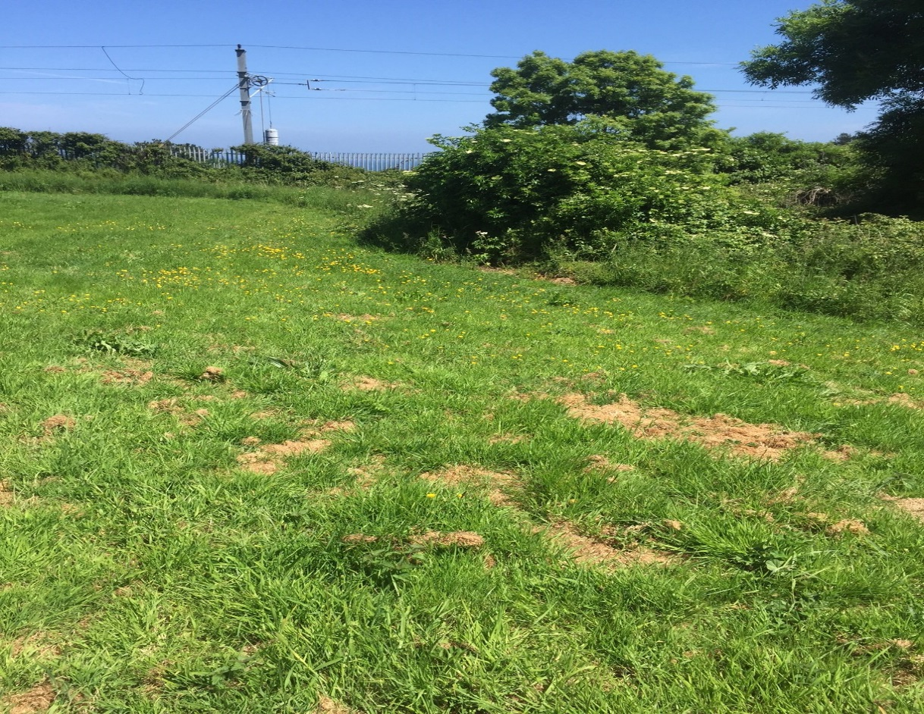
Figure 5 grassland and hedgerow adjacent to the DART line, june 2018

Grassland
The area of grassland is traversed by recently installed, good quality pathways that provide safe access for pedestrians and dogs. The remaining grassland is largely undisturbed and is mown on a regular basis. The grasslands have potential to be a more interesting species rich meadow if the mowing regime is altered and all cuttings removed from the sward, to reduce mulching and nourishment which benefits the improved grassland and weed growth at the expense of a wider, more diverse variety of flowering meadow species. There are small patches of Red Clover, Bloody Cransebill present and more widespread evidence of Dock, Nettle, Hogweed and Buttercup.
The maintenance of the grasslands is an on-going overhead. In 2017, the first full year of mowing, the first cut cost €500.00 & was paid for by the Council. The field had not been cut for some years so hence the relatively high cost of cutting. Local Residents have since taken on the responsibility of contracting mowing & paid the contractor €150.00 per cut. In all there were 8 cuts in 2017. Removal of the cut hay has not been carried out to date.

ACTIONS
- A meadow mowing regime is proposed to promote a more diverse structure with more native flowering plants to encourage pollinators. It is not thought practical or economic to re-seed the grassland area, instead a gradual reversion to a meadow will be attained through an appropriate mowing regime. Reseeding with meadow species and / or disturbance of the ground layer is not envisaged.
- It is essential to remove cuttings, post mowing and to discourage dumping of garden clippings and waste around the margins of the grassland.

- County Council to seek a quotation for topping and baling on an interval of six to eight weeks, starting in mid April and to include removal of all cut material from site, especially at the end of the grass growing season.

Mowing regime, Year One to Three:
- Cut in April, immediately after dandelions have flowered, (they are an important source of nectar for bees) and remove all cuttings if at all possible; Cut on a six to eight week cycle thereafter, bale and remove all cuttings. Dominant weeds such as Dock could be dug out manually, once a month in summer. Alternatively, Dock could be treated organically but not sprayed. A number of county councils now use organic weed control methods such as treatment with a strong solution of Vinegar, or acetic acid, (30% solution), in preference to use of pesticides which can be carcinogenic and damaging to wildlife and would require professional application.

- After soil fertility is weakened, and the meadow establishes, the mowing regime should be reviewed.

- Continue to close-cut margins of established pathways on a fortnightly basis to a width of a minimum of 1 meter on each side of the hard path and collect cuttings. Include seated areas and the fringe area around St. Crispins Cell in this fortnightly cut.

- Native wildflowers could be introduced into the relatively small area currently tilled and planted with garden perennials and bulbs of garden cultivars, adjacent to St. Crispins Cell.. This substitution will ensure a more appropriate, colourful display to benefit pollinators, in an area already prepared for flowering plants.

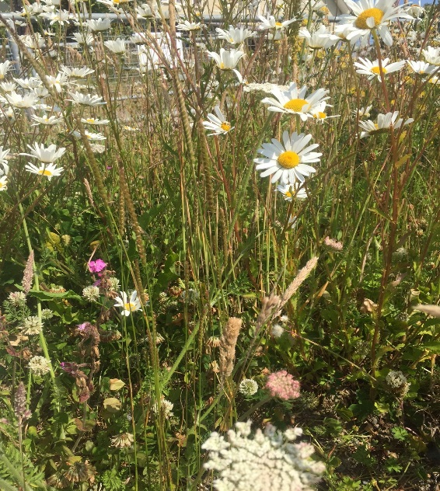
Figure 4 Wildflowers on a dry bank, Brittas Bay, june 2018

Suggested Native Wildflower list for area beside St Crispins Cell
Choose from:
- Field Scabious; Devil’s Bit Scabious, Oxeye Daisy, Purple Loosestrife, Selfheal, Knapweed, Birds foot Trefoil, Woundwort, Goldenrod

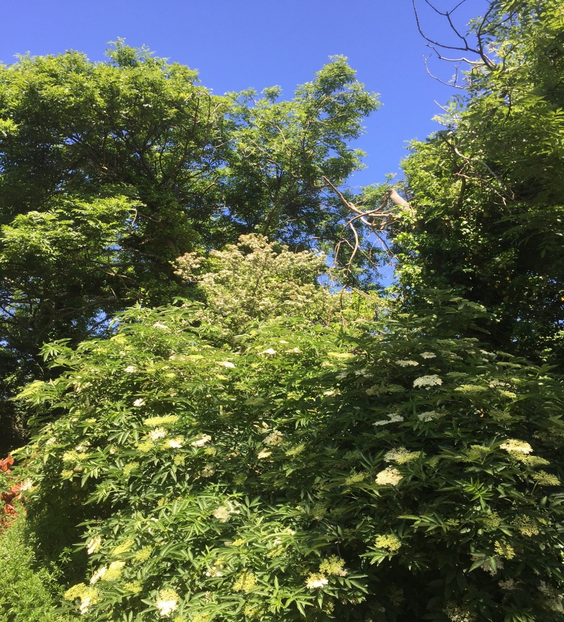
Figure 6 Elder, Hawthorn and Ash, Rathdown Park,june 2018

Woodland
A deciduous wood follows the line of the stream at the southern end of the site. Mature specimen trees of Ash, Willow and Hawthorn are of year-round interest to wildlife. Along the boundaries there are also mature Elder and Hawthorn which have flower and berry interest to wildlife.
ACTIONS
- The trees along the stream line would sustain a few nesting boxes for hole nesting bird species and should be assessed for suitability for deployment of bat boxes.
- Possible additional tree planting along the stream should include Alder, a high nature value native tree, tolerant of damp conditions.

Stream
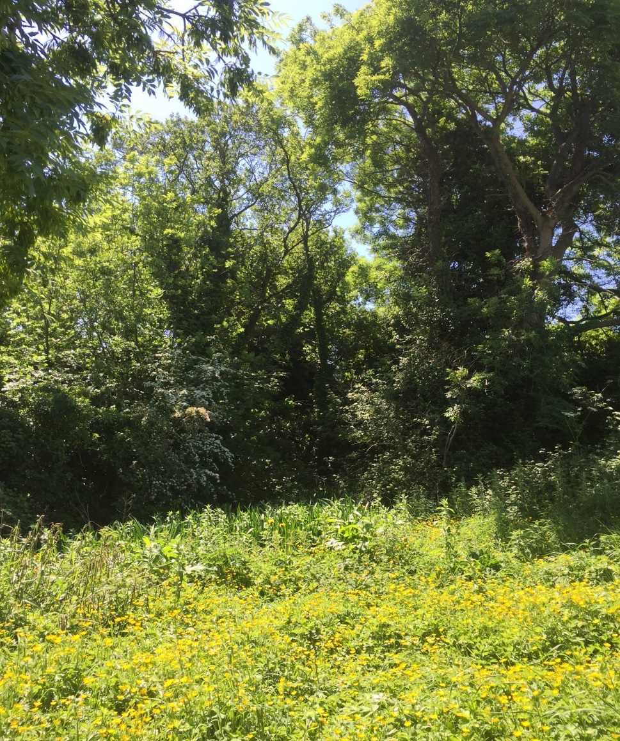
Figure 7 Flag Iris and Creeping Buttercup along stream, Rathdown Park, june 2018

The stream is fast flowing and clear and runs from west to east along the southern boundary. A patch of Yellow Flag Iris and Rosebay Willow Herb is situated along the margin of the stream, providing good ground cover for aquatic species and a good nectar source for pollinators. A search for riverine bird species such as Moorhen, Grey Wagtail and Dipper is advisable. Nesting opportunities exist or can be provided under the culvert bridge and in the Flag Iris bed.
ACTIONS
- A nest box for Grey Wagtail should be provided in the area of the culvert/bridge.
- Dumping of garden clippings and hardwood should be completely discouraged in this area.
- An inventory of riparian fauna and flora should be considered. This could be carried out by local school groups/projects.

Hedgerows
Native Hawthorn and Elder are well developed in patches around the site boundary. These provide berries for birds in autumn and winter as well as nectar for pollinators in spring and early summer.
ACTIONS
- A linear strip should be allowed to grow, uncut and flower naturally under the hedgerow boundary. This will encourage and protect small mammals and insects by providing cover.
- Hedgerow trees are best left to thrive as found, but if trimming is required for safety reason, this can be achieved on a rotational basis. The Wildlife Act currently excludes cutting between 1st March – 31st Aguust.

Stone Buildings
The ruins of farm buildings to the north of the site are important for wildlife as they provide dry, warm shelter with plenty of cover. St Crispins Cell has been secured and its stonework clean, but is now the location of a planting scheme more appropriate to a private garden. The appearance of climbing plants such as a Clematis montana which is secured against the end wall is worrying.
The farmhouse, though overgrown, is likely to be a haven for wildlife which shelter and nest in the mature ivy. This plant also provides important late autumn nectar on its flowers for butterflies and moths. The berries that follow in late winter are often the only such food available to wildlife at that time.
ACTIONS
- Because of the delicate nature of stonework at the farmhouse, no management of plant life should be undertaken in this area without prior consultation with Wicklow County Council.
- Planting around St Crispins Cell needs to be at the very least reviewed and an outcome agreed by all parties
- An Inventory of birds and bats occurring and nesting on the stone walls and surrounding area should be carried out. Similarly, a list of Butterfly species should be collected. These surveys are ideal for school or citizen science input.

Conclusions
The site has clearly benefitted from recent initiatives, by residents and council. This has resulted in clear signage, a new set of footpaths and a general clean up which has resulted in regular usage and a pride in the site.
A few actions need to be taken or modified to further encourage and improve biodiversity on the site. The daily usage by walkers and interested residents will ensure progress to meet agreed aims. The importance of the site to residents is immense, relative to its modest 2 hectare area.

Site Recommendations
- Seek a clear commitment by all concerned to review and reverse the practice of introducing garden plants to the area around St. Crispins Cell and the practice of disposing/dumping garden compost and plant waste on the margins of the wooded area.
- Adopt a 3 year meadow regime to grasslands
- Encourage local monitoring of wildlife species, including winter bird census.
- Seek to remove /reduce invasive weeds such as dock and coarser hogweeds from grassland using sustainable methods.
- Introduce native wildflowers to the currently planted /tilled area around St. Crispins Cell
- Encourage nest/bat box scheme in the wooded area
- Review and gauge potential interest and commitment to starting an allotment scheme or community garden in the north west corner of the site. If this is to go ahead, it should be in the form of raised and enclosed beds and will require careful management.
- Through Greystones Tidy Towns group, track actions for pollinators and consider entry to the L.A. Pollinator award of the National Tidy Towns competition.
- TT group to work with Environmental Awareness Office of WCC for best practice on composting.
- Encourage more widescale use of the area as a venue for local school fieldtrips e.g. under the Heritage In Schools Scheme, BT Young Scientists Competition or as a general venue for Bat Walks, Ladybird Surveys, Butterfly monitoring etc

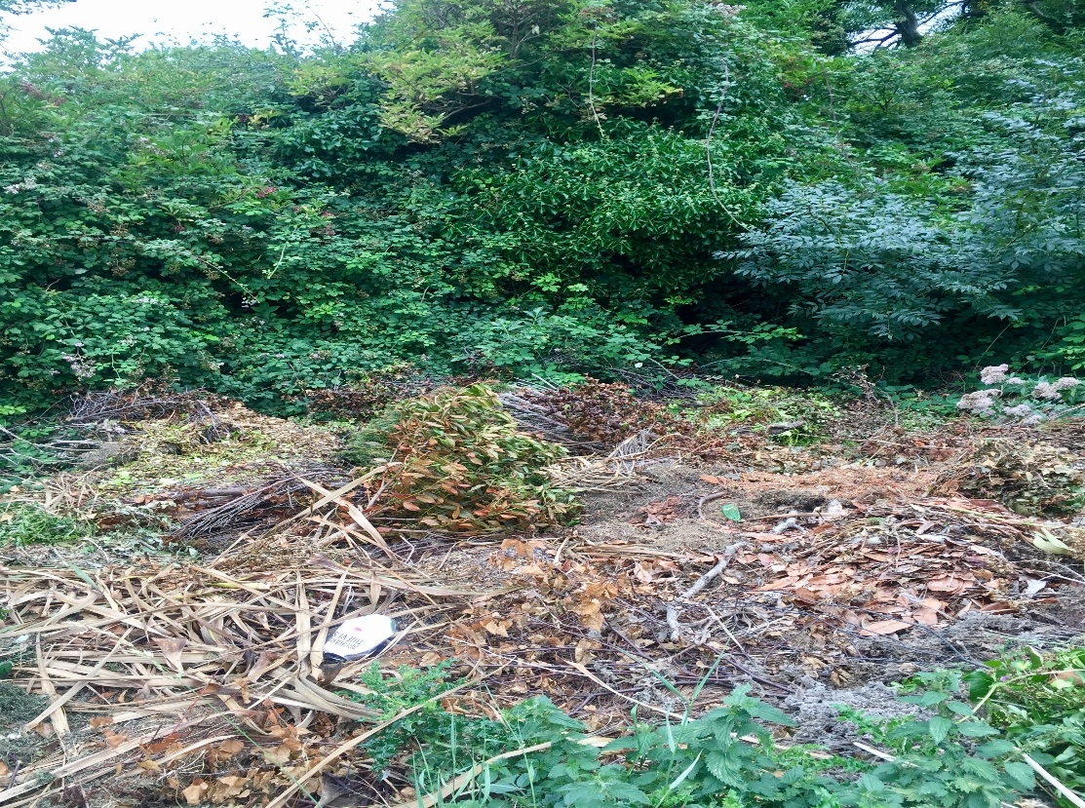
Figure 8 discarded hard and soft wood cuttings along steam boundary, August 2018
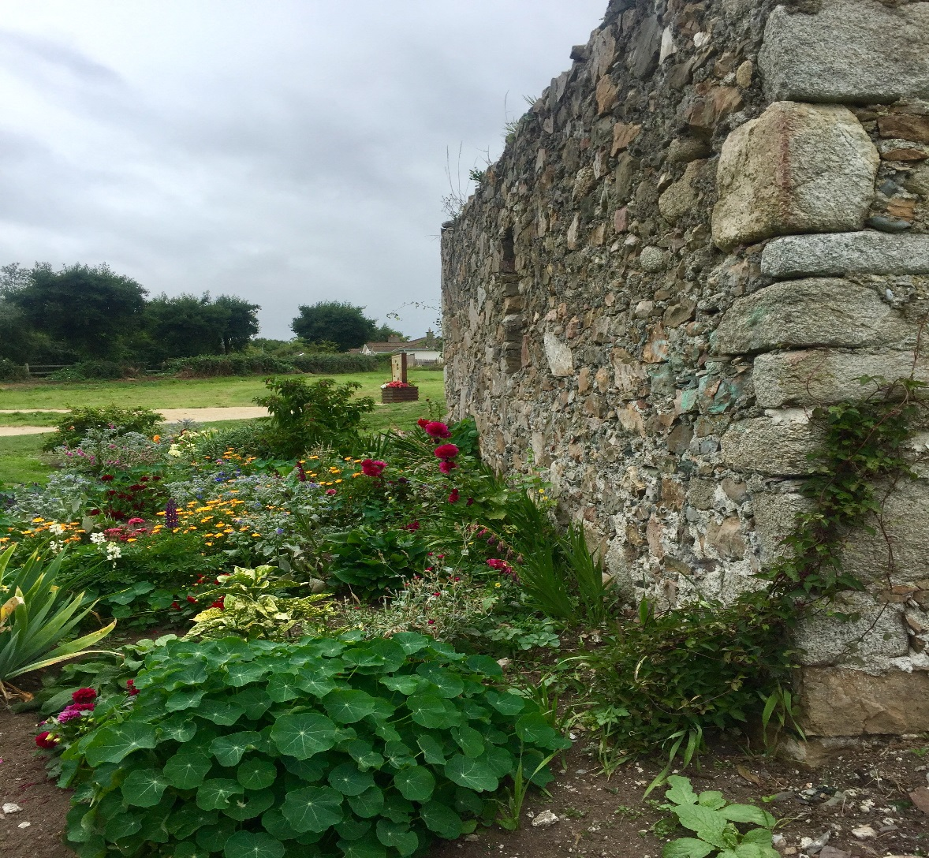
Figure 9 St Crispins cell with garden planting scheme, including Clematis montana in foreground, August 2018

Appendices

Native Plant lists
What plants are good for our pollinators?
Experts agree that inadequate nutrition is a major cause of pollinator declines. We want bees to be there when we need them, but our landscape doesn’t provide the abundance and diversity of flowering plants that they need to survive throughout their life cycle. To have a healthy balanced diet, bees need to be able to feed on pollen and nectar from a range of different flowers from early spring to autumn. In local areas this can be a mixture of native and deliberately planted species.

Native plants
It is very important that we increase the amount of native plants in our local areas to provide food for bees and other insects. Often we can do this by managing the land in a slightly different way than we have become used to:
* ( ) Brackets denote the flowering period of the plant
Plant more pollinator friendly native trees and shrubs:
- Hazel (Feb-Apr), Willow (Mar-May), Blackthorn (Mar-May), Hawthorn (Apr-Jun), Whitebeam (May-Jun), Rowan (May-Jun), Crab apple (Jun), Ivy (Sept-Nov). You should source stock of local provenance where possible.

Maintain hedgerows and grassy banks or verges to encourage pollinator friendly native plants:
- Hawthorn (Apr-Jun), Bramble (May-Sept), Wild Carrot (Jun-Sept), Hogweed (Jun-Sept), Goldenrod (Jul-Sept), Rosebay Willowherb (Jun-Sept), Woundworts (Jul-Sept), Ivy (Sept-Nov).
Have grassy meadows or areas of long grass to encourage pollinator friendly native plants:
- Dandelion (Mar-Oct), Vetch (Apr-Oct), Vetchling (May-Aug), Clovers (May-Oct), Bird’s foot trefoil (Jun-Sept), Knapweed (Jun-Oct), Scabious (Jun-Oct), Self-heal (Jun-Aug), Yarrow (Jun-Oct), Thistle (Jun-Oct), Wild marjoram (Jul-Sept).

Leave pavements, tracks or grassy edges unsprayed to encourage pollinator friendly native plants:
- Dead-nettle (Mar-Nov), Veronica (Mar-Sept), Forget-me-not (Apr-Sept), Geranium (Apr-Oct), Hawksbeard (Jun-Oct). 9 Allow small areas to grow wild. Depending on where you are, you will encourage these pollinator friendly native plants: Butterbur (Mar-May), Coltsfoot (Mar-Apr), Bluebell (Apr-May), Brassicas (Apr-Aug), Red Bartsia (Jun-Sept), Foxglove (Jun-Sept), Fleabane (Jul-Sept).
These lists are not exhaustive, they simply provide examples of common pollinator friendly, native plants that can be encouraged. The more native plants there are in our landscape the better, as they provide bees with a balanced diet.

Pollinator friendly containers around the Interpretive sign
Traditional bedding plants like Begonias, Busy Lizzy, Polyanthus, annual Geraniums and Petunias have virtually no pollen and nectar, so are of little value to pollinators. Try incorporating some pollinator friendly perennial options to create a pollinator friendly flower bed. mix pollinator friendly perennials with traditional bedding options, as perennial plants can look less attractive when they finish flowering

Five annuals for containers | Five perennials for containers
Sweet alyssum | Nepeta ‘Walkers Low’
Flossflower | Rudbeckia ‘Goldstrum’
Cosmea | Sedum spectable
Poached egg flower | Thymes
Garden heliotrope | Heathers, erica

Plant pollinator friendly bulbs for Interpretive sign container
Many commonly planted bulbs, like Daffodils and Tulips, are not good for pollinators. Increase the amount of flowers for pollinators in spring by planting pollinator friendly bulbs in autumn.
Six pollinator friendly bulbs
Snowdrop
Crocus
Allium
Grape Hyacinth
Single flowered Dahlia, especially Bishop series
Fritillaria

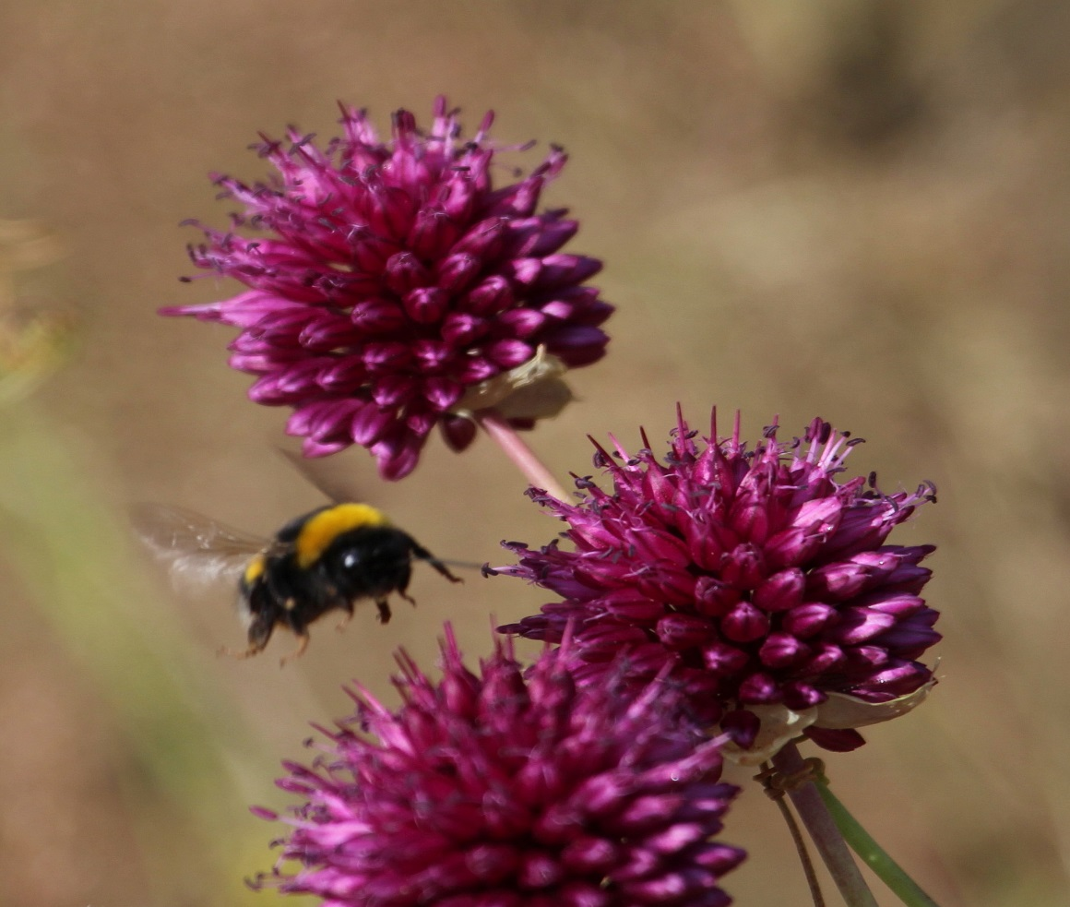
Figure 10 Bumblebee visits a container grown Allium plant.

Site Visits:
May, June, July and August 2018.
Members of the Swallow family, including Sand Martins, hawked for insects over the open grassland area. The latter breed locally in an important colony on the nearby low sandy sea cliffs. This colony extends to 47 active nests, as surveyed in July 2018. The area immediately east of the Rathdown site held singing Sedge Warblers and Whitethroats, two summer migrants typical of rough grassland and scrub areas. The adjacent farmed area currently holds a crop of Rapeseed, an important agriculture crop that depends on pollinating bee species. The ruined farm buildings and walls provide safe nesting areas for birds and bees. The proliferation of ivy is important for birds and insects that feed on its unique autumn flowers and late winter berries.
Other birds evident on a site visit in early June include House Sparrow, Swallow, House Martin, Swift, Goldfinch, Blackcap and Collared Dove.

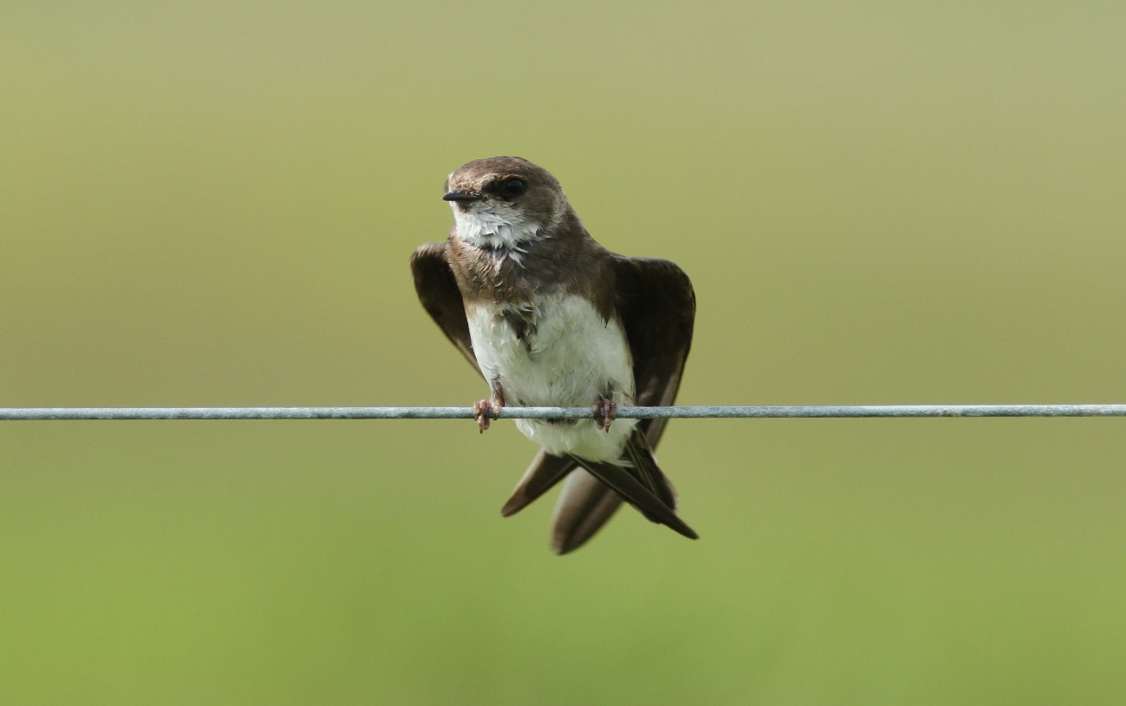
Figure 11 Sand Martin: a colony of 47 active nests is situated adjacent to Rathdown Park.

Reference
Rathdown Heritage Park Design Strategy Morgensen (2014)

Bibliography
Companion to Wildlife Gardening (Baines), RHS / Frances Lincoln
Insects of Ireland (Mc Cormack & Regan), Collins Press
Ireland’s Garden Birds (O’Sullivan & Wilson), 2nd edition 2017, Collins Press
No Nettles Required , the truth about wildlife gardening (Thompson), 2007, Eden Project Books.
The Wildflowers of Ireland (Devlin), (2016), Collins Press

Useful websites
www.biodiversityireland.ie
www.batconservationireland.org
www.pollinator.ie
www.wicklow.ie
www.irishgardenbirds.ie
www.birdwatchireland.ie

