New Insights into the Church known as St. Crispin’s Cell and the site of Rathdown Castle, Co. Wicklow (Frank Coyne, Ejvind Mogensen, Colin Love, John Harrington, Marie Burbridge and Paul Duffy)

Known to hikers and hillwalkers across the country, the iconic stone church known as St. Crispin’s Cell marks the beginning of the famous Greystones to Bray cliff walk. For the last number of years the Tidy Towns association in Greystones alongside the Redford Park Residents Association have been attempting to raise the profile of the public space surrounding St. Crispin’s Cell, combat anti-social behaviour raise awareness of the historical significance of the site to ensure that the space becomes an amenity integral to pubic life in the area. The following short paper details the archaeology of the area and outlines the results to date of an ongoing community archaeology project centred on the site.
Site location
St. Crispin’s Cell (WI008-012001), the site of Rathdown Castle (WI008-011001) and the associated deserted medieval village WI008-011002 are believed to represent all that remains of the highly significant medieval manor of Rathdown. These sites are located at the northern edge of Greystones in Co. Wicklow (Figure 1) in a dramatic coastal landscape which overlooks the sea cliffs above Greystones beach and rises to the north, towards the lower slopes of Bray Head (Figure 2).
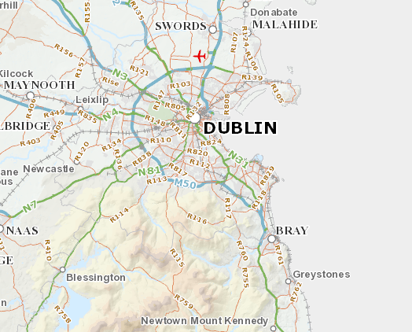
(Figure 1: Site Location)
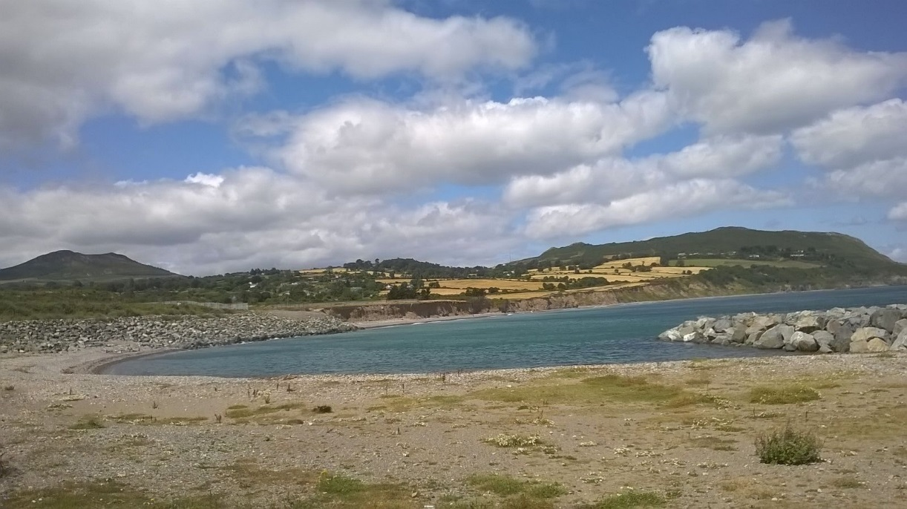
Figure 2: View northwest towards site of Rathdown Castle and Bray Head
St. Crispin’s Cell is located 200m to the southwest within a field accessible to the public (Figure 3). Vegetation is sparse, limited to the margins, and consists of brambles, shrubs and some low trees. A stream, cuts through the southern end of the site and a linear depression, runs along the western margin of the field, quite close to the Cell. This is called the “hollow way”, and may be part of an old road from the north of the county to the south. The Dublin-Wexford railway divides the area in two, with the Cell located on the western side of the line and the ‘Castle’ site to the east. The site of the castle is contained within a large field, now under cultivation, and an area of waste scrub. The Cell stands within an area of greenfield which also contains the remains of farm buildings associated with Captain Tarrant’s estate of the 18th century. This greenfield area is bordered to the north, west and south by modern developments and is traversed by a public footpath.
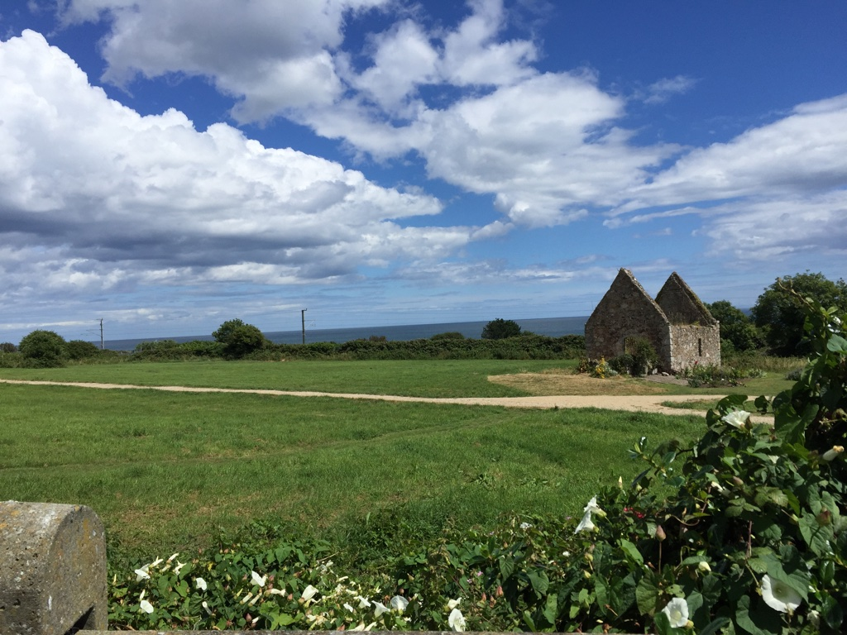
Figure 3: View east showing St. Crispin’s Cell and surrounding field
History of the site
Canon Price suggests that the ‘Rath’ of Rathdown was one of the royal residences of the mythical Erimon, the reputed first Milesian king of Ireland and several references to Rath Oinn in the sources have been associated with Rathdown though this has been disputed by later scholars. Whilst archaeological excavation has confirmed Gaelic settlement in the area immediately west of the Cell (in the form of ringfort WI008-073), the earliest secure reference to a manor at Rathdown is contained in the Book of Howth, where ‘Rachdoun’ is described as a manor held from the king by John son of Dermot, who was almost certainly the grandson of Donal Mac Giolla Mocholmog, Chief of Uí Dunchadha. The Mo-Cholmoc clan, unlike some of their neighbours realised early on that their fate depended on maintaining good relations with whoever controlled Dublin. Donal’s negotiations with the head of the Anglo-Norman garrison, Miles de Cogan ensured that he would retain the manor of Rathdown, a grant later confirmed by Henry II.
Rathdown Castle was built c.1200, and comprised a moated enclosure, a single square tower (possibly later), and walls 1.2m thick. It was surrounded by a double-ditch enclosure entered by a causeway to the north. Rathdown Well was located by the side of the Castle, and supplied water to the settlement.
St. Crispin’s Cell, named after the French martyr, is a small, single-celled church, with a porch at the west side, which has been dated to pre-1530. It is presumed to be associated with the medieval manor of Rathdown. However, given the attested presence of early medieval archaeology in the vicinity, an oval earthwork that surrounds the cell is thought to represent possible evidence for an early medieval ecclesiastical enclosure. Antiquarian reports state that a graveyard, near St. Crispin’s Cell, was dug up by Colonel Tarrant, owner of nearby Tarrant’s farmhouse in the 18th century. These burials may have related to an earlier foundation.
The Manor of Rathdown is described in 1534 as ‘containing a Castle, 20 messuages, 248 acres, a water-mill and a river called the ‘Water of Rathdown’ (Figure 4) as well as a Crykka (small inlet/ bay) which may indicate a port. Greystones first appears on the map of Wicklow in 1760, though the hamlets of Redford and Rathdown are shown on Senex and Maxwell’s Map of Ireland 1712. Evidence of a village was discovered in the 18th century, when the draining of a field resulted in the discovering of the remains of a paved street. The medieval village was the centre of the Barony of Rathdown, which stretched from Delgany to Merrion Gates in Dublin. Canon Digby Scott, in his book The stones of Bray, describes it as “one of the finest Baronies in Ireland”.
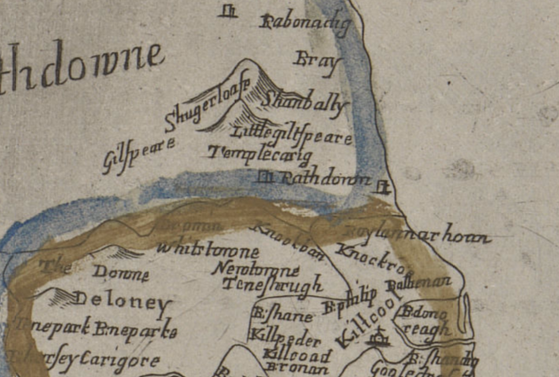
(Figure 4: The Down Survey Barony Map of Rathdown with the castle visible)
Tarrant’s Farmhouse is an early two-storey house, built c.1710. The farmhouse is of considerable architectural and aesthetic interest for the quality of random field-stone work of almost flint-like quality, and the incorporation of granite slabs which may have been taken from Rathdown Castle itself. In 1771, it became the home of Col. Charles Tarrant. Tarrant was a reputed antiquarian, surveyor, architect, artist and cartographer who worked with the Wide Streets Commission on the layout of Georgian Dublin, and supervised the building of the Grand Canal. The rumour that he organised the levelling of the remains of Rathdown village would seem to be out of character. The farmhouse was occupied into the 1980’s. From this point on it has gradually become a ruin.
Previous Investigations at the site
In 1990, the site was threatened by proposed development. An intensive project of archaeological and historical investigation was launched, driven by local residents. The resulting society, ‘The Friends of Historic Rathdown’ published a book in 1993 which detailed the history of the site and presented the ensemble of information gathered. As a result of vigorous campaigning, the proposed scale of the proposed development was curtailed and Wicklow County Council acquired the land surrounding St. Crispin’s Cell and Tarrant’s farmhouse in order to preserve both the upstanding and subsurface archaeology. A huge debt is owed to those involved in the original crusade. Without their actions, Rathdown, as we know it, would not have survived for this and future generations.
Issues affecting the site
Despite the action taken by the local community 20 years ago, there has been a backslide in the intervening years with local appreciation of the importance of the site no longer as focused as it once was. A complicating factor has been the decline of the field surrounding St. Crispin’s Cell which in recent years has become overgrown and has been the site of anti-social behaviour and illegal dumping.
In addition to these problems, aggressive coastal erosion, making inroads into the glacial soils of the site, has also been responsible for carrying away valuable archaeological information at the site of the castle. The strong erosion, if not stopped, will soon cause the underground remains of Rathdown Castle site to wash into the sea.
Community Archaeology Geophysical survey results
These negative effects on the local heritage prompted Greystones Tidy Towns and the Redford Park Residents Association to take action and, with the support of Wicklow County Council, interpretive panels were designed, a new pathway installed and the vegetation cleared (Figure 5). As a part of this initiative, a geophysical survey of the St. Crispin’s site and the field encompassing the north of the Rathdown Castle site was commissioned.
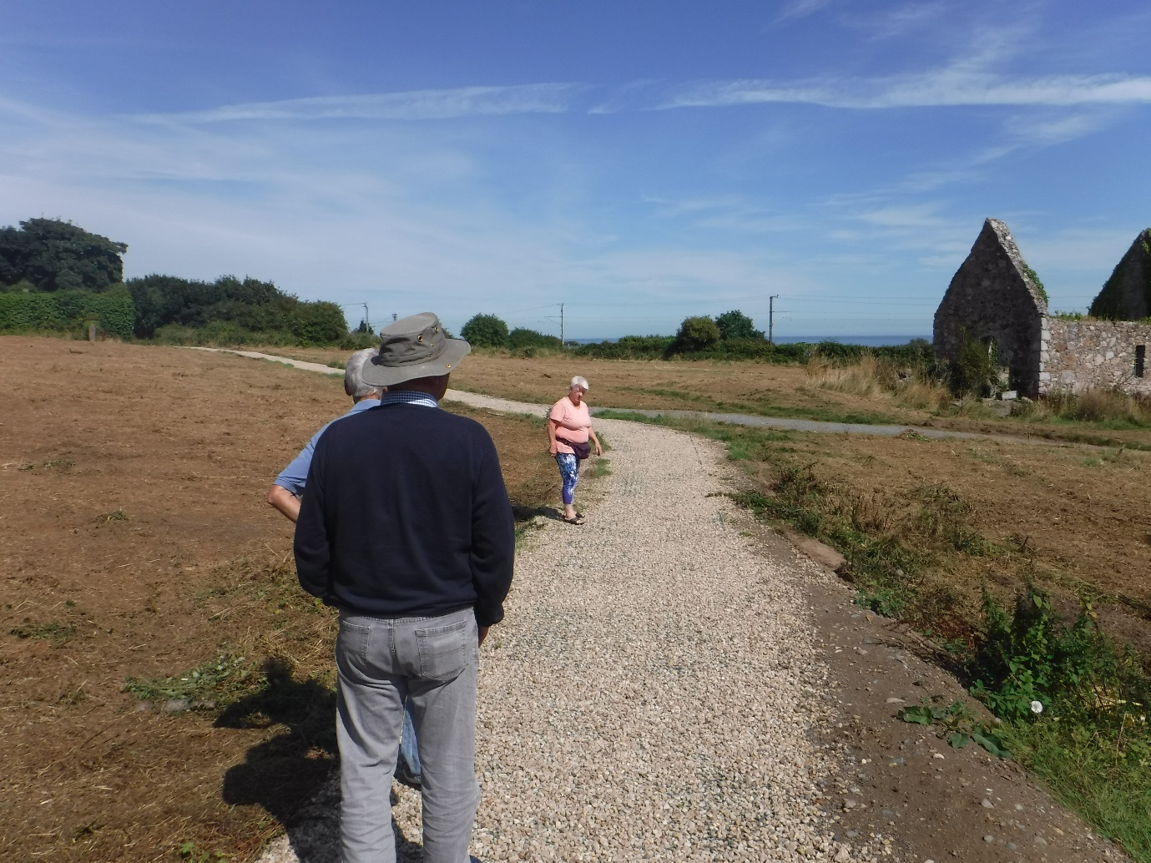
Figure 5: members of the Redford Park Resident’s Association on new pathway onsite
A gradiometer and resistance survey was undertaken in September 2016 by Joanna Leigh (Figure 6). The gradiometer data in Areas A and B were affected by modern magnetic disturbance, mostly resulting from the adjacent DART train line. The resistance survey in Area was severely affected by contact resistance, resulting from the densely matted vegetation. Nevertheless, responses of potential interest were recorded.

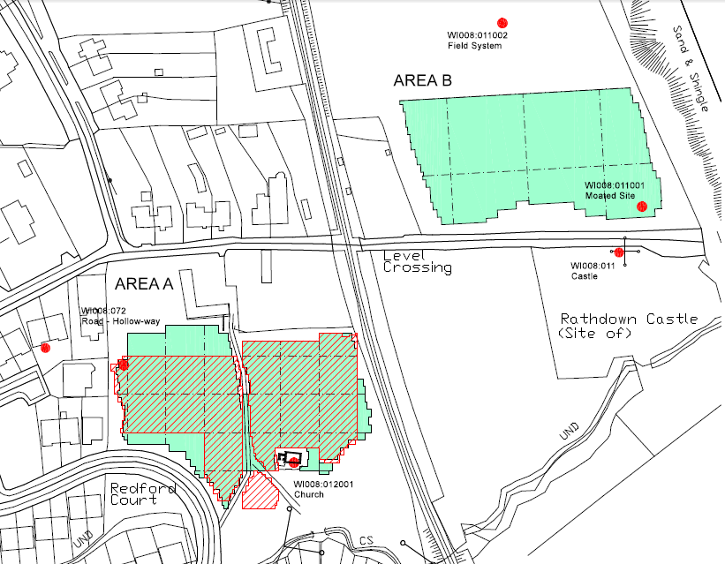
(Figure 6: Geophysical survey areas)
In Area A (St Crispin’s Church) the gradiometer survey identified responses likely to represent ditch-type features, perhaps associated with a small field system extending from the, now ruined, St Crispin’s Church (Figure 7).
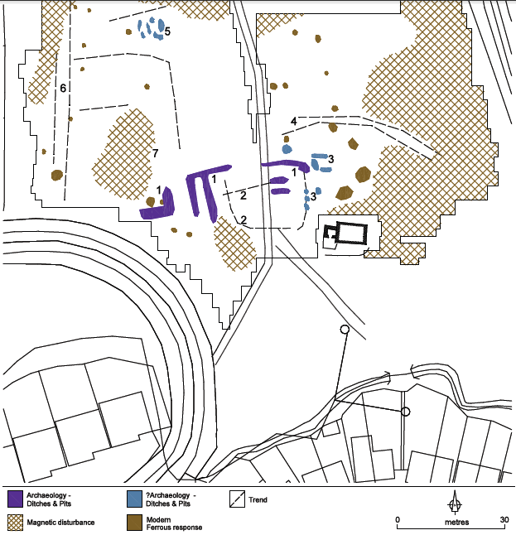
(Figure 7: Gradiometer results in Area A)
Parallel faint linear trends to the north of the church are evident in the gradiometer data. These show some correlation with the results of the resistance survey. It is possible that the outer boundary of the church is located here (Figure 8).
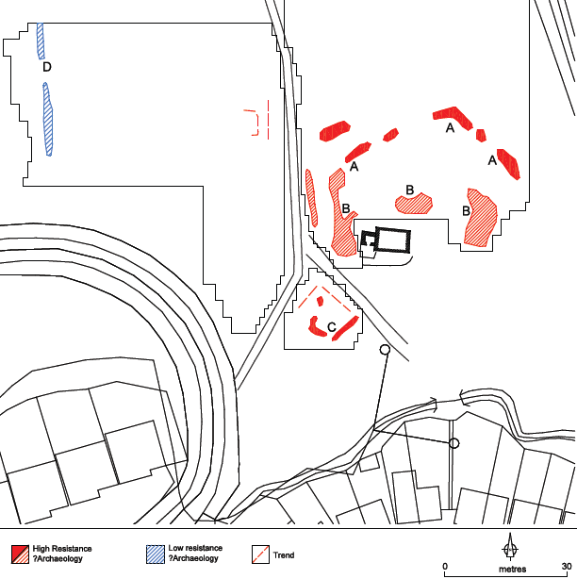
(Figure 8: Resistance survey results, Area A)
In the west of Area A, both the gradiometer and resistance survey detected linear trends and responses (6) and (D). These correlate with the location of a recorded Hollow-way (WI008:072). A cluster of responses (5) in the gradiometer data may represent pit-type features. There are no corresponding responses in the resistance survey and interpretation is cautious. This may represent more recent activity.
In Area B, detailed gradiometer survey was positioned to investigate the recorded moated site (WI008:011001). The results detected responses indicative of archaeological activity. The responses identified are fragmented. There is clear correlation with the Cambridge Series aerial photograph of the 1960s (Figure 9) but much of the site has remained undetected in the data, with the responses identified having a fragmented appearance. This suggests this site has been heavily plough damaged. Nevertheless, the responses are indicative of a former field system, with ditched boundary features and clear ploughing trends (Figure 10).
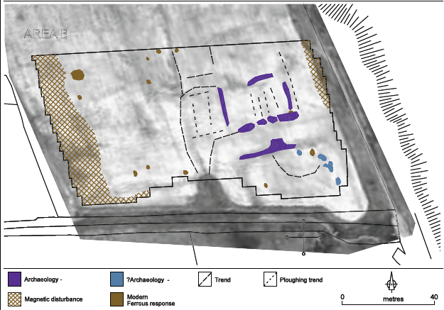
Figure 10: Interpreted survey results in Area B
The survey has successfully provided confirmation of an archaeological site at the location of the recorded moated site and, in addition to medieval features in the field surrounding St. Crispin’s Cell. Perhaps the most exciting result has been the identification of a potential curving enclosure surrounding the Cell. This adds additional weight to the long-held belief that the Cell may in fact be located on the site of an earlier, pre-Norman foundation.
Outcomes and objectives
The members of Greystones Tidy Towns, conscious of the untapped heritage and alarmed at the deterioration of the buildings are now playing an active part in improving and preserving the site. The walls of Crispin’s cell which were stabilised in the last ten years, need further maintenance and work which will shortly be undertaken by Wicklow County Council following a grant from the Heritage Council. All weather paths have been installed by Wicklow County Council bringing increased visitors to the site. Regular ‘clean ups’ and the cutting back of bramble etc. have been instigated. Greystones Tidy Towns has also designed signage which will outline to the visiting public the history and heritage of the site. It is hoped to foster community involvement through further archaeological research at the site. Feasibility for a targeted excavation to test the results of the geophysical survey is being explored. Such a project, with help from local clubs and schools, might help stimulate a sense of ownership and a duty of care for the area in present and future generations. More efforts will be made to raise public interest, by inviting school visits, and having guided tours of the site. We plan to install seating so strollers can enjoy the peaceful surroundings.
It is also intended to establish a wildflower meadow, where flowers, heather and wild grasses would grow, to encourage birds, bees and other insects, creating a natural environment. We hope to encourage community gardening by establishing some raised areas where flowers and vegetables could be grown without disturbing the ground surface. Other aspirations include a playground made from natural materials, a freshwater ecology pond for schools, and the re-instatement of the annual ecumenical service in the Cell.
In the long term, we envisage an interpretive centre, where artefacts/reproductions/ drawings could be viewed. With funding, we believe the 18th century ‘Tarrant’s Farmhouse’ would be perfect and appropriate for such a centre.
Acknowledgements
Greystones Tidy Towns and Redford Park Residents’ Association would like to thank Joanna Leigh of J.M Leigh Surveys and Deirdre Burns, Heritage Officer with Wicklow County Council for their input and assistance to date.
Further Reading:
Digby Scott, G. The stones of Bray: and the stories they can tell of ancient times in the barony of Rathdown Bray 1913.
Fitzgerald W. ‘The manor and castle of Powerscourt, Co Wicklow’, Journal County Kildare Archaeological Society, 6, 1909-11, 129.
Smal, C. Ancient Rathdown and St. Crispin’s Cell. The Friends of Historic Rathdown, Greystones 1993.

