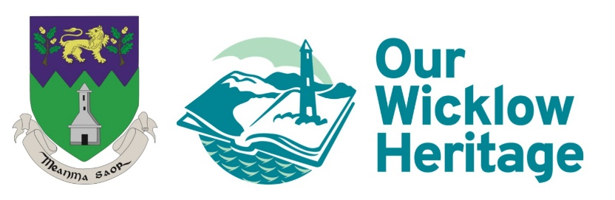

County Wicklow Heritage Plan 2024-2028, Public Consultation Survey

What do we mean by heritage?
We are surrounded by our built, natural, and cultural heritage from monuments, buildings, historic places, collections in museums and archives to landscapes, seascapes, geology, and wildlife. Our heritage also includes our social history, culture, music, sport, customs, crafts, traditional skills, and folklore. Heritage reflects our past, enriches our present and is a legacy for future generations to enjoy.

We want to hear your views
Wicklow County Council is about to develop the fourth County Wicklow Heritage Plan (2024-2028). The plan will set out how we will protect and manage our heritage and connect people with it in a sustainable way. As part of the process, we want to hear the views of both organisations and individual members of the community with an interest in Wicklow’s heritage. Tell us what you value and want to see prioritised, protected and celebrated. Thank you for completing the survey, we value your views.

- Before completing this survey had you heard of the County Wicklow Heritage Plan?

Yes No Don’t know

- Why is Wicklow's Heritage important to you? (Tick as many as apply)
Sense of community
Our story/social history
It is an irreplaceable resource
It enhances our environment and where we live
Economic and tourism benefits
Sense of place
Environmental sustainability
Well-being
None of the above

If there are other reasons that heritage is important to you, please tell us
________________________________________________________________________________________________________________________________________________________________________________________________________________________________________________________________________________________________________________________________________________________________________________________________________________________________________________________________________________________________

- What do you feel are the priority themes related to managing heritage (1 is highest
priority 5 is lowest priority).

Theme/area | 1  Highest priority | 2 | 3 | 4 | 5  Lowest priority | No  opinion
Conserve and care for natural and cultural heritage.
Inclusion of heritage considerations in local authority decision making.
More focus on Wicklow’s unique heritage (buildings, oral histories, placenames, landscapes).
Managing heritage to address climate change and biodiversity loss.
Recording and researching areas of heritage that are under recorded.
Providing educational resources, and guidance on heritage conservation and management.

Strengthen and grow partnerships to protect heritage.

- What do you feel are the priority themes relating to connecting people to heritage (1 is
highest priority, 5 is lowest priority).

Theme/area | 1  Highest priority | 2 | 3 | 4 | 5  Lowest priority | No  opinion
Support and build capacity within communities to actively engage with local heritage.
Make heritage more accessible to all.
Raising awareness, celebrating, and communicating heritage.
Providing heritage training e.g., recording biodiversity,
Community archaeology, local history research.

- Would you like to suggest any other area/theme to be included in the Plan that is not listed above?
________________________________________________________________________________________________________________________________________________________________________________________________________________________________________________________________________________________________
- What do you think are the main challenges or threats facing Wicklow’s Heritage?
________________________________________________________________________________________________________________________________________________________________________________________________________________________________________________________________________________________________________________________________________________________________________________________________________________________________________________________________________________________________

- What would make it easier for people to engage with Wicklow's heritage?
________________________________________________________________________________________________________________________________________________________________________________________________________________________________________________________________________________________________________________________________________________________________________________________________________________________________________________________________________________________________
- Are you interested in taking part in any of the following types of community heritage
project or training? (you can tick more than one)
Recording headstones in local graveyards  Recording biodiversity e.g., birds, insects, plants | Community archaeology projects e.g., digs  Local history research
Are there other types of community heritage project or training you’d be interested in?
________________________________________________________________________________________________________________________________________________________________________________________________________________________________________________________________________________________________
- If you are answering the survey as an individual
Please indicate your age _________________________
Prefer not to say
- Please indicate your gender
Male Female Other Prefer not to say
- If you are answering the survey on behalf of a group or organisation, what is the name of your organisation or group? (Organisation name will be included in list of consultees in the County Wicklow Heritage Plan 2024-2028)
________________________________________________________________________________________________________________________________________________________________________________________________
- What type of organisation is it?

Heritage group (history, wildlife)  Arts or culture group  School | Business  Sports club | Youth group  Residents' association
Other please specify: ________________________________________________________________________________________________________________________________________________________________________________________________
Thank you!

